**FAST ALUMNI MANAGEMENT SYSTEM**

DB PROJECT MID EVALUATION

MEMBERS:

22K-4504 Muhammad Ashir

22K-4471 Muhammad Ashar Ali

22K-4625 Sayal Baig

**DATA REQUIRED:**

• User_ID

• User_CNIC

• User_FullName

• User_NuID

• User_DoB

• User_EmailID

• User_MobileNo

• User_PasswordHashed

• User_Campus

• User_CurrentCountry

• User_CurrentCity

• User_Profile_Picture

• User_Role

• User_IsActive

• User_DateCreated

• User_Lastupdated

• User_Department

• Alumni_ProfileID

• Alumni_UserID

• Alumni_Organization

• Alumni_CurrentPosition

• Alumni_LinkedInProfile

• Alumni_Industry

• Alumni_ProfessionalSummary

• Alumni_PrivacySettings

• Student_UserID

• Student_CurrentYear

• Student_CurrentSemester

• Student_GPA

• Event_ID

• Event_Name

• Event_Description

• Event_Date

____________________________________________________________________________DATA REQUIRED_

• Event_Time

• Event_Location

• Event_OrganizerID

• Event_MaxParticipants

• Event_RegistrationDeadline

• Event_banner

• Event_ParticipantCount

• Event_CreatedDate

• Event_Type

• Registration_ID

• Registration_EventID

• Registration_UserID

• Registration_Date

• Registration_TicketNumber

• Registration_Status

• Donation_ID

• Donation_UserID

• Donation_Amount

• Donation_PaymentMethod

• Donation_TransactionID

• Donation_Date

• Donation_Note

• Job_ID

• Job_Type

• Job_SalaryRange

• Job_ExperienceLevel

• Job_Title

• Job_Description

• Job_CompanyName

• Job_Location

• Job_Applicationlink

• Job_PostedBy

• Job_DatePosted

• Job_deadline

• Mentorship_ID

• Mentor_ID

• Mentee_ID

• Mentorship_StartDate

• MentorShip_EndDate

• Mentorship_Objectives

• Mentorship_status

• Feedback_ID

• Feedback_givenby

• Feedback_receivedby

• Feedback_Text

____________________________________________________________________________DATA REQUIRED_

• Feedback_rating

• Feedback_date

• News_ID

• News_title

• News_Content

• News_AuthorID

• News_PostedDate

• NewsThumbnailImage

• News_Tags

• Forum_ID

• Forum_Name

• Forum_Description

• Forum_Createdby

• Forum_DateCreated

• Post_ID

• Post_ForumID

• Post_PostedBy

• Post_Content

• Post_AttachmentURL

• Post_Date

• Post_Status

• Review_ID

• Reviewer_ID

• Reviewee_ID

• Review_Text

• Review_Rating

• Review_Date

• Report_ID

• Report_UserID

• Report_GraduationYear

• Report_Industry

• Report_SalaryRange

• Report_Date

• Project_ID

• Project_Name

• Project_Description

• Project_CreatedBy

• Project_Collaborators

• Project_StartDate

• Project_Enddate

• Project_Status

• Help_ID

___________________________________________________________________NORMALIZATION_PROCESS_

• Help_title

• Help_Content

• Help_Section

• Help_LastUpdated

• Help_Visibility

• Help_Author

**Normalization Process**

**Normalizing to 1 NF:**

1NF requires:

* Each column contains atomic values (no multivalued attributes).
* Each column contains values of a single type.
* Each row is unique, identified by a primary key.

**Action for 1NF:**

* Identify repeating groups and multivalued attributes.
* Split them into separate tables.

**Analysis for 1NF:**

From the provided attributes, no repeating groups or multivalued attributes are evident. However, we need to ensure every table has a primary key and atomic values.

**Resultant Tables for 1NF:**

**User Table**  
| **User_ID (PK)** | User_CNIC | User_FullName | User_NuID | User_DoB | User_EmailID | User_MobileNo | User_PasswordHashed | User_Campus | User_CurrentCountry | User_CurrentCity | User_Profile_Picture | User_Role | User_IsActive | User_DateCreated | User_LastUpdated | User_Department |

**Alumni Table**  
| **Alumni_ProfileID (PK)** | Alumni_UserID (FK) | Alumni_Organization | Alumni_CurrentPosition | Alumni_LinkedInProfile | Alumni_Industry | Alumni_ProfessionalSummary | Alumni_PrivacySettings |

**Student Table**  
| **Student_UserID (PK, FK)** | Student_CurrentYear | Student_CurrentSemester | Student_GPA |

**Event Table**  
| **Event_ID (PK)** | Event_Name | Event_Description | Event_Date | Event_Time | Event_Location | Event_OrganizerID | Event_MaxParticipants | Event_RegistrationDeadline | Event_Banner | Event_ParticipantCount | Event_CreatedDate | Event_Type |

________________________________________________________________________________1 NF FORM_

**Registration Table**  
| **Registration_ID (PK)** | Registration_EventID (FK) | Registration_UserID (FK) | Registration_Date | Registration_TicketNumber | Registration_Status |

**Donation Table**  
| **Donation_ID (PK)** | Donation_UserID (FK) | Donation_Amount | Donation_PaymentMethod | Donation_TransactionID | Donation_Date | Donation_Note |

**Job Table**  
| **Job_ID (PK)** | Job_Type | Job_SalaryRange | Job_ExperienceLevel | Job_Title | Job_Description | Job_CompanyName | Job_Location | Job_Applicationlink | Job_PostedBy | Job_DatePosted | Job_Deadline |

**Mentorship Table**  
| **Mentorship_ID (PK)** | Mentor_ID (FK) | Mentee_ID (FK) | Mentorship_StartDate | Mentorship_EndDate | Mentorship_Status |

**Feedback Table**  
| **Feedback_ID (PK)** | Feedback_GivenBy (FK) | Feedback_ReceivedBy (FK) | Feedback_Text | Feedback_Rating | Feedback_Date |

**News Table**  
| **News_ID (PK)** | News_Title | News_Content | News_AuthorID (FK) | News_PostedDate | News_ThumbnailImage | News_Tags |

**Forum Table**  
| **Forum_ID (PK)** | Forum_Name | Forum_Description | Forum_CreatedBy (FK) | Forum_DateCreated |

**Post Table**  
| **Post_ID (PK)** | Post_ForumID (FK) | Post_PostedBy (FK) | Post_Content | Post_AttachmentURL | Post_Date | Post_Status |

**Review Table**  
| **Review_ID (PK)** | Reviewer_ID (FK) | Reviewee_ID (FK) | Review_Text | Review_Rating | Review_Date |

**Report Table**  
| **Report_ID (PK)** | Report_UserID (FK) | Report_GraduationYear | Report_Industry | Report_SalaryRange | Report_Date |

**Project Table**  
| **Project_ID (PK)** | Project_Name | Project_Description | Project_CreatedBy (FK) | Project_Collaborators | Project_StartDate | Project_EndDate | Project_Status |

**Help Table**  
| **Help_ID (PK)** | Help_Title | Help_Content | Help_Section | Help_LastUpdated | Help_Visibility | Help_Author (FK) |

_____________________________________________________________________2 NF FORM + 3 NF FORM_

**Normalizing 2 NF:**

2NF requires:

* The table is in 1NF.
* All non-key attributes are fully functionally dependent on the primary key (no partial dependency).

**Action for 2NF:**

* Identify and remove partial dependencies by creating new tables for attributes only partially dependent on composite keys.

##### ****Analysis for 2NF:****

* TableFeedback have partial dependencies on composite keys.

##### ****Resultant Tables for 2NF:****

**Feedback Table**  
| **Feedback_ID (PK)** | Feedback_GivenBy (FK) | Feedback_ReceivedBy (FK) |

**FeedbackDetails Table**  
| **Feedback_ID (PK, FK)** | Feedback_Text | Feedback_Rating | Feedback_Date |

**Normalizing to 3 NF:**

**3NF requires:**

* The table is in **2NF**.
* No **transitive dependency** (non-key attributes depend only on the primary key).

**Action for 3NF:**

* Remove transitive dependencies by creating new tables.

**Analysis for 3NF:**

* In the **User Table**, attributes like User_CurrentCountry and User_CurrentCity are directly related to the user and not dependent on any other attribute. These are not transitive dependencies and can remain in the **User Table**.
* However, in the **Project Table**, the attribute Project_Collaborators introduced a **transitive dependency**. The collaborators' details (e.g., roles, statuses) depend not only on the Project_ID but also on individual collaborators themselves.

_______________________________________________________________________________BCNF FORM_

**Resolution:**

* To remove this transitive dependency, the Project_Collaborators attribute was normalized into a separate **Collaboration Table**.
  + The **Project Table** now only contains project-specific details.
  + The new **Collaboration Table** represents the many-to-many relationship between Projects and Users and includes attributes like Collaboration_Role, Collaboration_JoinDate, and Collaboration_Status.

**Project Table**

| **Project_ID (PK)** | Project_Name | Project_Description | Project_CreatedBy (FK) | Project_Collaborators | Project_StartDate | Project_EndDate | Project_Status |

**Collaboration Table**

| **Collaboration_ID (PK)** | Collaboration_ProjectID | Collaboration_UserID | Collaboration_Role | Collaboration_JoinDate | Collaboration_Status |

**BCNF:**

BCNF requires:

* The table is in 3NF.
* Every determinant is a candidate key.

**Action for BCNF:**

* Further split tables if any determinant exists that isn't a candidate key.

##### ****Analysis for BCNF:****

Most tables already satisfy BCNF as primary keys are clearly defined. If any anomalies arise, further decomposition might be necessary.

##### ****Resultant Tables for BCNF:****

No additional changes beyond 3NF are required.

_______________________________________________________________FINAL ENTITIES AND ATTRIBUTES

**FINAL ENTITIES AND ATTRIBUTES:**

#### **1. User Table**

| **User_ID (PK)** | User_CNIC | User_FullName | User_NuID | User_DoB | User_EmailID | User_MobileNo | User_PasswordHashed | User_Campus | User_Profile_Picture | User_Role | User_IsActive | User_DateCreated | User_LastUpdated | User_Department | User_CurrentCountry | User_CurrentCity |

#### **2. Alumni Table**

| **Alumni_ProfileID (PK)** | Alumni_UserID (FK) | Alumni_Organization | Alumni_CurrentPosition | Alumni_LinkedInProfile | Alumni_Industry | Alumni_ProfessionalSummary | Alumni_PrivacySettings |

#### **3. Student Table**

| **Student_UserID (PK, FK)** | Student_CurrentYear | Student_CurrentSemester | Student_GPA |

#### **4. Event Table**

| **Event_ID (PK)** | Event_Name | Event_Description | Event_Date | Event_Time | Event_Location | Event_OrganizerID (FK) | Event_MaxParticipants | Event_RegistrationDeadline | Event_Banner | Event_ParticipantCount | Event_CreatedDate | Event_Type |

#### **5. Registration Table**

| **Registration_ID (PK)** | Registration_EventID (FK) | Registration_UserID (FK) | Registration_Status | Registration_Date

#### **6. Donation Table**

| **Donation_ID (PK)** | Donation_UserID (FK) | Donation_Title | Donation_description | Donation_TargetedAmount | Donation_AmountRaised | Donation_Date | Donation_deadline | Donation_Status | Donation_Category

#### **7. Job Table**

| **Job_ID (PK)** | Job_Type | Job_SalaryRange | Job_ExperienceLevel | Job_Title | Job_Description | Job_CompanyName | Job_Location | Job_ApplicationLink | Job_PostedBy (FK) | Job_DatePosted | Job_Deadline | Job_Tags

#### **8. Mentorship Table**

| **Mentorship_ID (PK)** | Mentor_ID (FK) | Mentee_ID (FK) | Mentorship_StartDate | Mentorship_EndDate | Mentorship_Status | Mentorship_Objectives | Mentorship Notes

#### **9. Feedback Table**

| **Feedback_ID (PK)** | Feedback_GivenBy (FK) | Feedback_ReceivedBy (FK) |

_______________________________________________________________FINAL ENTITIES AND ATTRIBUTES

#### **10. FeedbackDetails Table**

| **Feedback_ID (PK, FK)** | Feedback_Text | Feedback_Rating | Feedback_Date |

#### **11. News Table**

| **News_ID (PK)** | News_Title | News_Content | News_AuthorID (FK) | News_PostedDate | News_ThumbnailImage | News_Tags |

#### **12. Forum Table**

| **Forum_ID (PK)** | Forum_Name | Forum_Description | Forum_CreatedBy (FK) | Forum_DateCreated |

#### **13. Post Table**

| **Post_ID (PK)** | Post_ForumID (FK) | Post_PostedBy (FK) | Post_Content | Post_AttachmentURL | Post_Date | Post_Status | Post_bannerImage |

#### **14. Review Table**

| **Review_ID (PK)** | Reviewer_ID (FK) | Reviewee_ID (FK) | Review_Text | Review_Rating | Review_Date |

#### **15. Report Table**

| **Report_ID (PK)** | Report_UserID (FK) | Report_GraduationYear | Report_Industry | Report_SalaryRange | Report_Date | Report_Image |

#### **16. Project Table**

| **Project_ID (PK)** | Project_Name | Project_Description | Project_CreatedBy (FK) | Project_StartDate | Project_EndDate | Project_Status |

#### **17. Collaboration Table**

| **Collaboration_ID (PK)** | Collaboration_ProjectID | Collaboration_UserID | Collaboration_Role | Collaboration_JoinDate | Collaboration_Status |

#### **18. Help Table**

| **Help_ID (PK)** | Help_Title | Help_Content | Help_Section | Help_LastUpdated | Help_Visibility | Help_Author (FK) |

____________________________________________________________RELATIONSHIPS AND MULTIPLICITY _

**RELATIONSHIPS AND MULTIPLICITY:**

#### **1. User ↔ Alumni**

* **Role:** Alumni extends User.
* **Description:** Each alumni is a user, but not every user is an alumni. Alumni-specific data is stored in the Alumni table.
* **Foreign Key:** Alumni_UserID
* **References From:** User.User_ID
* **Multiplicity:**
  + **1 User : 0 or 1 Alumni**
  + A user can have at most one alumni profile.

#### **2. User ↔ Student**

* **Role:** Student extends User.
* **Description:** Students are users with specific academic attributes like year, semester, and GPA.
* **Foreign Key:** Student_UserID
* **References From:** User.User_ID
* **Multiplicity:**
  + **1 User : 0 or 1 Student**
  + A user can be either a student or an alumni, but not both simultaneously.

#### **3. User ↔ Event (Organizer)**

* **Role:** User as an event organizer.
* **Description:** A user can organize multiple events, but an event can have only one organizer.
* **Foreign Key:** Event_OrganizerID
* **References From:** User.User_ID
* **Multiplicity:**
  + **1 User : 0 or Many Events**
  + A user can organize multiple events, but each event has only one organizer.

#### **4. Event ↔ Registration**

* **Role:** Registration links users to events.
* **Description:** A user can register for multiple events, and each event can have many registrations.
* **Foreign Key:**
  + Registration_EventID → Event.Event_ID
  + Registration_UserID → User.User_ID
* **Multiplicity:**
  + **1 Event : 0 or Many Registrations**
  + **1 User : 0 or Many Registrations**

#### **5. User ↔ Donation**

* **Role:** User as a donor.
* **Description:** A user can make multiple donations.

____________________________________________________________RELATIONSHIPS AND MULTIPLICITY _

* **Foreign Key:** Donation_UserID
* **References From:** User.User_ID
* **Multiplicity:**
  + **1 User : 0 or Many Donations**

#### **6. User ↔ Job (PostedBy)**

* **Role:** User as a job poster.
* **Description:** A user can post multiple jobs, and each job is posted by one user.
* **Foreign Key:** Job_PostedBy
* **References From:** User.User_ID
* **Multiplicity:**
  + **1 User : 0 or Many Jobs**

#### **7. User ↔ Mentorship (Mentor/Mentee)**

* **Role:** Mentor and Mentee in mentorship.
* **Description:** A mentorship involves one mentor and one mentee, both of whom are users.
* **Foreign Keys:**
  + Mentor_ID → User.User_ID
  + Mentee_ID → User.User_ID
* **Multiplicity:**
  + **1 Mentor (User) : 0 or Many Mentorships**
  + **1 Mentee (User) : 0 or Many Mentorships**

#### **8. User ↔ Feedback (GivenBy/ReceivedBy)**

* **Role:** Feedback links users who provide and receive feedback.
* **Description:** Users can exchange feedback with each other.
* **Foreign Keys:**
  + Feedback_GivenBy → User.User_ID
  + Feedback_ReceivedBy → User.User_ID
* **Multiplicity:**
  + **1 User : 0 or Many Feedbacks Given**
  + **1 User : 0 or Many Feedbacks Received**

#### **9. Feedback ↔ FeedbackDetails**

* **Role:** Details enrich feedback.
* **Description:** Each feedback has additional details like text and rating stored in a separate table.
* **Foreign Key:** Feedback_ID
* **References From:** Feedback.Feedback_ID
* **Multiplicity:**
  + **1 Feedback : 1 FeedbackDetails**

____________________________________________________________RELATIONSHIPS AND MULTIPLICITY _

#### **10. User ↔ News**

* **Role:** User as the author of news.
* **Description:** A user can post multiple news items, and each news item is authored by one user.
* **Foreign Key:** News_AuthorID
* **References From:** User.User_ID
* **Multiplicity:**
  + **1 User : 0 or Many News Items**

#### **11. Forum ↔ Post**

* **Role:** Forum as the container of posts.
* **Description:** A forum contains multiple posts, and each post belongs to one forum.
* **Foreign Key:** Post_ForumID
* **References From:** Forum.Forum_ID
* **Multiplicity:**
  + **1 Forum : 0 or Many Posts**

#### **12. User ↔ Post**

* **Role:** User as the creator of posts.
* **Description:** A user can create multiple posts, and each post is authored by one user.
* **Foreign Key:** Post_PostedBy
* **References From:** User.User_ID
* **Multiplicity:**
  + **1 User : 0 or Many Posts**

#### **13. User ↔ Peer Review**

* **Role:** Reviewer and Reviewee in peer reviews.
* **Description:** Users can review each other.
* **Foreign Keys:**
  + Reviewer_ID → User.User_ID
  + Reviewee_ID → User.User_ID
* **Multiplicity:**
  + **1 Reviewer (User) : 0 or Many Peer Reviews**
  + **1 Reviewee (User) : 0 or Many Peer Reviews**

#### **14. User ↔ Salary Report**

* **Role:** User as the reporter.
* **Description:** A user can submit multiple salary reports.
* **Foreign Key:** Report_UserID
* **References From:** User.User_ID

____________________________________________________________RELATIONSHIPS AND MULTIPLICITY _

* **Multiplicity:**
  + **1 User : 0 or Many Salary Reports**

#### **15. Help ↔ User**

* **Role:** User as the author of help content.
* **Description:** A user can author help entries.
* **Foreign Key:** Help_Author
* **References From:** User.User_ID
* **Multiplicity:**
  + **1 User : 0 or Many Help Entries**

#### **16. Project ↔ Collaboration**

* **Role:** Collaboration links projects to users as collaborators.
* **Description:** A project can have multiple collaborators, and a user can collaborate on multiple projects.
* **Foreign Key:**
  + Collaboration_ProjectID → Project.Project_ID
* **Multiplicity:**
  + **1 Project : 0 or Many Collaborations**

#### **17. User ↔ Collaboration**

* **Role:** Users are collaborators in projects.
* **Description:** A user can have multiple collaborations across projects.
* **Foreign Key:**
  + Collaboration_UserID → User.User_ID
* **Multiplicity:**
  + **1 User : 0 or Many Collaborations**

__________________________________________________________ENTITIES BLUE PRINT DATA MODELER_

**ENTITIES BLUE PRINT IN DATA MODELER:**

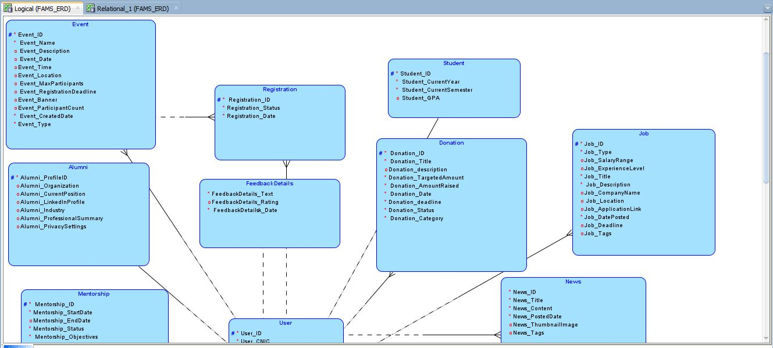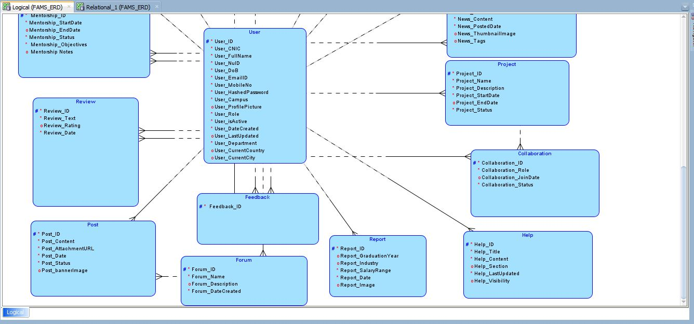

___________________________________________________ER-DIAGRAM WITH CARDINALITY CONSTRAINT_

**ER-DIAGRAM WITH CARDINALITY CONSTRAINT:**

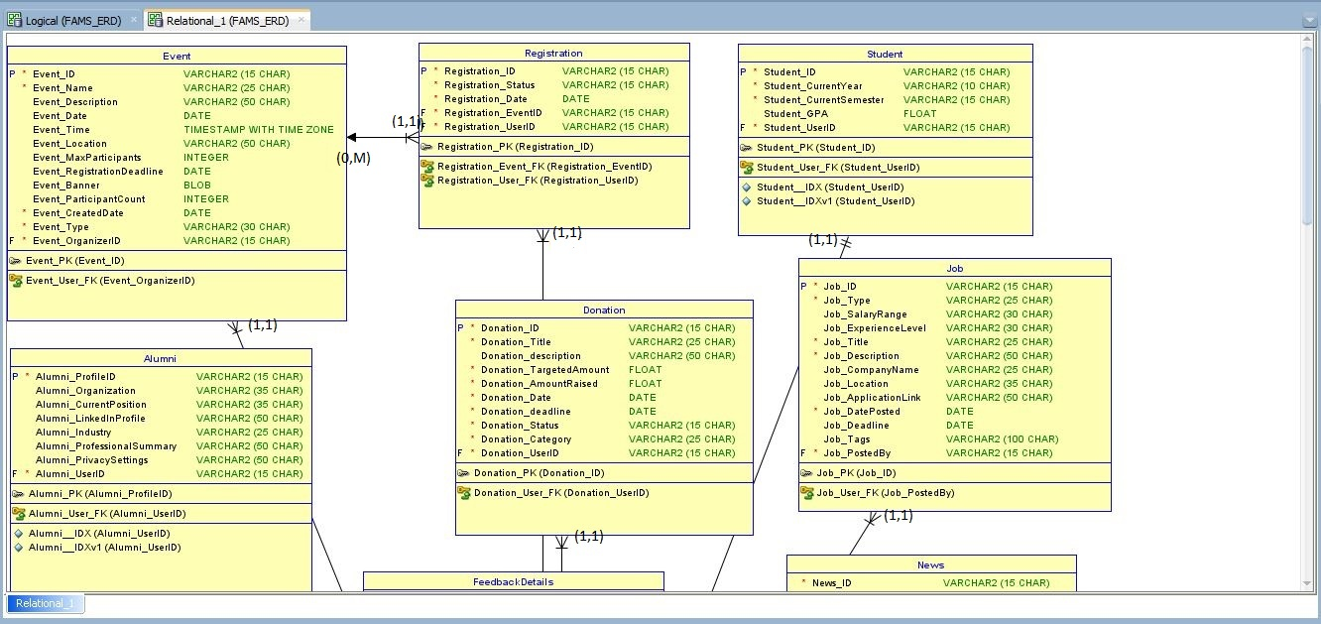

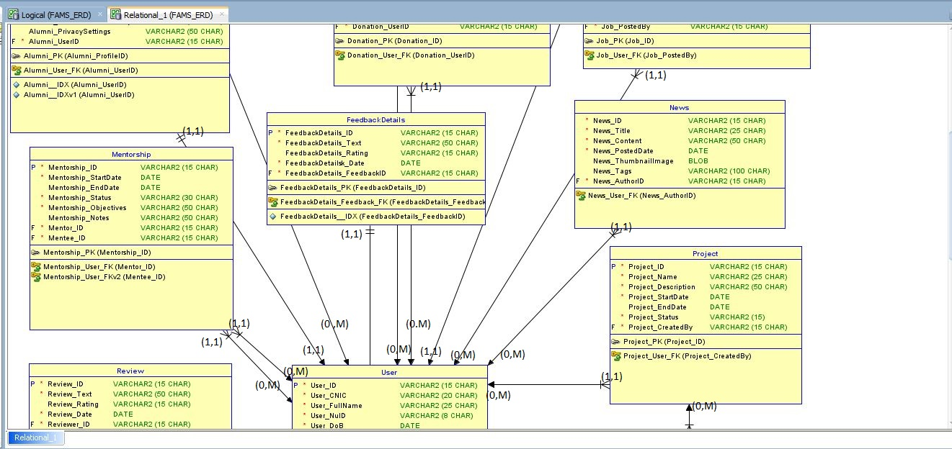

___________________________________________________ER-DIAGRAM WITH CARDINALITY CONSTRAINT_

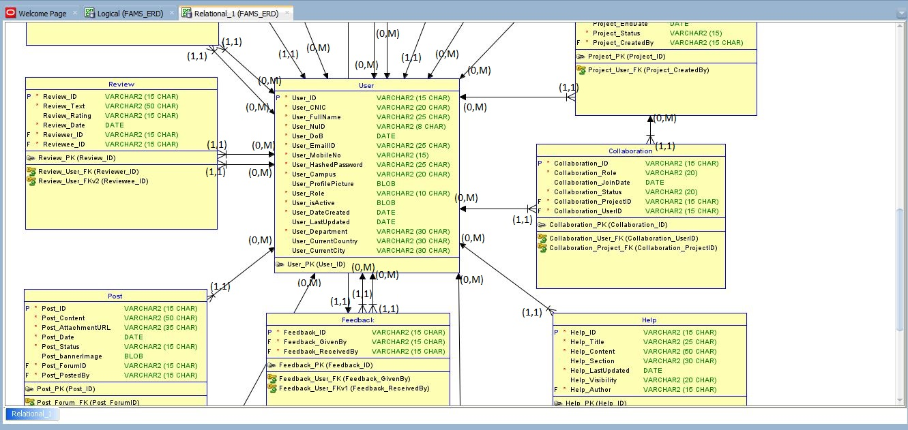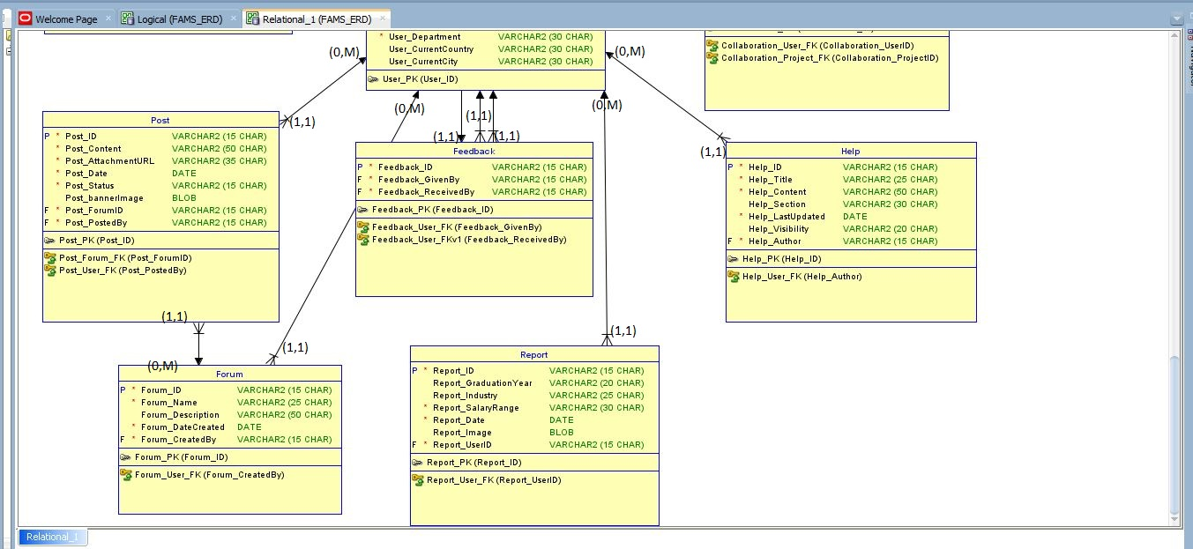

________________________________________________________________________GENERATED SCHEMA_

**GENERATED SCHEMA:**

**-- Generated by Oracle SQL Developer Data Modeler 23.1.0.087.0806**

**-- at: 2024-11-20 22:44:43 PKT**

**-- site: Oracle Database 11g**

**-- type: Oracle Database 11g**

**-- predefined type, no DDL - MDSYS.SDO_GEOMETRY**

**-- predefined type, no DDL - XMLTYPE**

**CREATE TABLE alumni (**

**alumni_profileid VARCHAR2(15 CHAR) NOT NULL,**

**alumni_organization VARCHAR2(35 CHAR),**

**alumni_currentposition VARCHAR2(35 CHAR),**

**alumni_linkedinprofile VARCHAR2(50 CHAR),**

**alumni_industry VARCHAR2(25 CHAR),**

**alumni_professionalsummary VARCHAR2(50 CHAR),**

**alumni_privacysettings VARCHAR2(50 CHAR),**

**alumni_userid VARCHAR2(15 CHAR) NOT NULL**

**);**

**CREATE UNIQUE INDEX alumni__idx ON**

**alumni (**

**alumni_userid**

**ASC );**

**CREATE UNIQUE INDEX alumni__idxv1 ON**

**alumni (**

**alumni_userid**

**ASC );**

**ALTER TABLE alumni ADD CONSTRAINT alumni_pk PRIMARY KEY ( alumni_profileid );**

**CREATE TABLE collaboration (**

**collaboration_id VARCHAR2(15 CHAR) NOT NULL,**

**collaboration_role VARCHAR2(20) NOT NULL,**

**collaboration_joindate DATE,**

**collaboration_status VARCHAR2(20) NOT NULL,**

**collaboration_projectid VARCHAR2(15 CHAR) NOT NULL,**

**collaboration_userid VARCHAR2(15 CHAR) NOT NULL**

**);**

**ALTER TABLE collaboration ADD CONSTRAINT collaboration_pk PRIMARY KEY ( collaboration_id );**

**CREATE TABLE donation (**

**donation_id VARCHAR2(15 CHAR) NOT NULL,**

**donation_title VARCHAR2(25 CHAR) NOT NULL,**

**donation_description VARCHAR2(50 CHAR),**

**donation_targetedamount FLOAT NOT NULL,**

**donation_amountraised FLOAT NOT NULL,**

**donation_date DATE NOT NULL,**

**donation_deadline DATE NOT NULL,**

**donation_status VARCHAR2(15 CHAR) NOT NULL,**

**donation_category VARCHAR2(25 CHAR) NOT NULL,**

**donation_userid VARCHAR2(15 CHAR) NOT NULL**

**);**

________________________________________________________________________GENERATED SCHEMA_

**ALTER TABLE donation ADD CONSTRAINT donation_pk PRIMARY KEY ( donation_id );**

**CREATE TABLE event (**

**event_id VARCHAR2(15 CHAR) NOT NULL,**

**event_name VARCHAR2(25 CHAR) NOT NULL,**

**event_description VARCHAR2(50 CHAR),**

**event_date DATE,**

**event_time TIMESTAMP WITH TIME ZONE,**

**event_location VARCHAR2(50 CHAR),**

**event_maxparticipants INTEGER,**

**event_registrationdeadline DATE,**

**event_banner BLOB,**

**event_participantcount INTEGER,**

**event_createddate DATE NOT NULL,**

**event_type VARCHAR2(30 CHAR) NOT NULL,**

**event_organizerid VARCHAR2(15 CHAR) NOT NULL**

**);**

**ALTER TABLE event ADD CONSTRAINT event_pk PRIMARY KEY ( event_id );**

**CREATE TABLE feedback (**

**feedback_id VARCHAR2(15 CHAR) NOT NULL,**

**feedback_givenby VARCHAR2(15 CHAR) NOT NULL,**

**feedback_receivedby VARCHAR2(15 CHAR) NOT NULL**

**);**

**ALTER TABLE feedback ADD CONSTRAINT feedback_pk PRIMARY KEY ( feedback_id );**

**CREATE TABLE feedbackdetails (**

**feedbackdetails_id VARCHAR2(15 CHAR) NOT NULL,**

**feedbackdetails_text VARCHAR2(50 CHAR) NOT NULL,**

**feedbackdetails_rating VARCHAR2(15 CHAR),**

**feedbackdetailsk_date DATE NOT NULL,**

**feedbackdetails_feedbackid VARCHAR2(15 CHAR) NOT NULL**

**);**

**CREATE UNIQUE INDEX feedbackdetails__idx ON**

**feedbackdetails (**

**feedbackdetails_feedbackid**

**ASC );**

**ALTER TABLE feedbackdetails ADD CONSTRAINT feedbackdetails_pk PRIMARY KEY ( feedbackdetails_id );**

**CREATE TABLE forum (**

**forum_id VARCHAR2(15 CHAR) NOT NULL,**

**forum_name VARCHAR2(25 CHAR) NOT NULL,**

**forum_description VARCHAR2(50 CHAR),**

**forum_datecreated DATE NOT NULL,**

**forum_createdby VARCHAR2(15 CHAR) NOT NULL**

**);**

**ALTER TABLE forum ADD CONSTRAINT forum_pk PRIMARY KEY ( forum_id );**

**CREATE TABLE help (**

**help_id VARCHAR2(15 CHAR) NOT NULL,**

**help_title VARCHAR2(25 CHAR) NOT NULL,**

**help_content VARCHAR2(50 CHAR) NOT NULL,**

**help_section VARCHAR2(30 CHAR),**

**help_lastupdated DATE NOT NULL,**

**help_visibility VARCHAR2(20 CHAR),**

**help_author VARCHAR2(15 CHAR) NOT NULL**

**);**

**ALTER TABLE help ADD CONSTRAINT help_pk PRIMARY KEY ( help_id );**

**CREATE TABLE job (**

**job_id VARCHAR2(15 CHAR) NOT NULL,**

________________________________________________________________________GENERATED SCHEMA_

**job_type VARCHAR2(25 CHAR) NOT NULL,**

**job_salaryrange VARCHAR2(30 CHAR),**

**job_experiencelevel VARCHAR2(30 CHAR),**

**job_title VARCHAR2(25 CHAR) NOT NULL,**

**job_description VARCHAR2(50 CHAR) NOT NULL,**

**job_companyname VARCHAR2(25 CHAR),**

**job_location VARCHAR2(35 CHAR),**

**job_applicationlink VARCHAR2(50 CHAR),**

**job_dateposted DATE NOT NULL,**

**job_deadline DATE,**

**job_tags VARCHAR2(100 CHAR),**

**job_postedby VARCHAR2(15 CHAR) NOT NULL**

**);**

**ALTER TABLE job ADD CONSTRAINT job_pk PRIMARY KEY ( job_id );**

**CREATE TABLE mentorship (**

**mentorship_id VARCHAR2(15 CHAR) NOT NULL,**

**mentorship_startdate DATE NOT NULL,**

**mentorship_enddate DATE,**

**mentorship_status VARCHAR2(30 CHAR) NOT NULL,**

**mentorship_objectives VARCHAR2(50 CHAR) NOT NULL,**

**mentorship_notes VARCHAR2(50 CHAR),**

**mentor_id VARCHAR2(15 CHAR) NOT NULL,**

**mentee_id VARCHAR2(15 CHAR) NOT NULL**

**);**

**ALTER TABLE mentorship ADD CONSTRAINT mentorship_pk PRIMARY KEY ( mentorship_id );**

**CREATE TABLE news (**

**news_id VARCHAR2(15 CHAR) NOT NULL,**

**news_title VARCHAR2(25 CHAR) NOT NULL,**

**news_content VARCHAR2(50 CHAR) NOT NULL,**

**news_posteddate DATE NOT NULL,**

**news_thumbnailimage BLOB,**

**news_tags VARCHAR2(100 CHAR),**

**news_authorid VARCHAR2(15 CHAR) NOT NULL**

**);**

**CREATE TABLE post (**

**post_id VARCHAR2(15 CHAR) NOT NULL,**

**post_content VARCHAR2(50 CHAR) NOT NULL,**

**post_attachmenturl VARCHAR2(35 CHAR) NOT NULL,**

**post_date DATE NOT NULL,**

**post_status VARCHAR2(15 CHAR) NOT NULL,**

**post_bannerimage BLOB,**

**post_forumid VARCHAR2(15 CHAR) NOT NULL,**

**post_postedby VARCHAR2(15 CHAR) NOT NULL**

**);**

**ALTER TABLE post ADD CONSTRAINT post_pk PRIMARY KEY ( post_id );**

**CREATE TABLE project (**

**project_id VARCHAR2(15 CHAR) NOT NULL,**

**project_name VARCHAR2(25 CHAR) NOT NULL,**

**project_description VARCHAR2(50 CHAR) NOT NULL,**

**project_startdate DATE NOT NULL,**

**project_enddate DATE,**

**project_status VARCHAR2(15) NOT NULL,**

**project_createdby VARCHAR2(15 CHAR) NOT NULL**

**);**

**ALTER TABLE project ADD CONSTRAINT project_pk PRIMARY KEY ( project_id );**

**CREATE TABLE registration (**

**registration_id VARCHAR2(15 CHAR) NOT NULL,**

**registration_status VARCHAR2(15 CHAR) NOT NULL,**

________________________________________________________________________GENERATED SCHEMA_

**registration_date DATE NOT NULL,**

**registration_eventid VARCHAR2(15 CHAR) NOT NULL,**

**registration_userid VARCHAR2(15 CHAR) NOT NULL**

**);**

**ALTER TABLE registration ADD CONSTRAINT registration_pk PRIMARY KEY ( registration_id );**

**CREATE TABLE report (**

**report_id VARCHAR2(15 CHAR) NOT NULL,**

**report_graduationyear VARCHAR2(20 CHAR),**

**report_industry VARCHAR2(25 CHAR),**

**report_salaryrange VARCHAR2(30 CHAR) NOT NULL,**

**report_date DATE NOT NULL,**

**report_image BLOB,**

**report_userid VARCHAR2(15 CHAR) NOT NULL**

**);**

**ALTER TABLE report ADD CONSTRAINT report_pk PRIMARY KEY ( report_id );**

**CREATE TABLE review (**

**review_id VARCHAR2(15 CHAR) NOT NULL,**

**review_text VARCHAR2(50 CHAR) NOT NULL,**

**review_rating VARCHAR2(15 CHAR),**

**review_date DATE NOT NULL,**

**reviewer_id VARCHAR2(15 CHAR) NOT NULL,**

**reviewee_id VARCHAR2(15 CHAR) NOT NULL**

**);**

**ALTER TABLE review ADD CONSTRAINT review_pk PRIMARY KEY ( review_id );**

**CREATE TABLE student (**

**student_id VARCHAR2(15 CHAR) NOT NULL,**

**student_currentyear VARCHAR2(10 CHAR) NOT NULL,**

**student_currentsemester VARCHAR2(15 CHAR) NOT NULL,**

**student_gpa FLOAT,**

**student_userid VARCHAR2(15 CHAR) NOT NULL**

**);**

**CREATE UNIQUE INDEX student__idx ON**

**student (**

**student_userid**

**ASC );**

**CREATE UNIQUE INDEX student__idxv1 ON**

**student (**

**student_userid**

**ASC );**

**ALTER TABLE student ADD CONSTRAINT student_pk PRIMARY KEY ( student_id );**

**CREATE TABLE "User" (**

**user_id VARCHAR2(15 CHAR) NOT NULL,**

**user_cnic VARCHAR2(20 CHAR) NOT NULL,**

**user_fullname VARCHAR2(25 CHAR) NOT NULL,**

**user_nuid VARCHAR2(8 CHAR) NOT NULL,**

**user_dob DATE NOT NULL,**

**user_emailid VARCHAR2(25 CHAR) NOT NULL,**

**user_mobileno VARCHAR2(15) NOT NULL,**

**user_hashedpassword VARCHAR2(25 CHAR) NOT NULL,**

**user_campus VARCHAR2(20 CHAR) NOT NULL,**

**user_profilepicture BLOB,**

**user_role VARCHAR2(10 CHAR) NOT NULL,**

**user_isactive BLOB NOT NULL,**

**user_datecreated DATE NOT NULL,**

**user_lastupdated DATE,**

**user_department VARCHAR2(30 CHAR) NOT NULL,**

________________________________________________________________________GENERATED SCHEMA_

**user_currentcountry VARCHAR2(30 CHAR),**

**user_currentcity VARCHAR2(30 CHAR)**

**);**

**ALTER TABLE "User" ADD CONSTRAINT user_pk PRIMARY KEY ( user_id );**

**ALTER TABLE alumni**

**ADD CONSTRAINT alumni_user_fk FOREIGN KEY ( alumni_userid )**

**REFERENCES "User" ( user_id );**

**ALTER TABLE collaboration**

**ADD CONSTRAINT collaboration_project_fk FOREIGN KEY ( collaboration_projectid )**

**REFERENCES project ( project_id );**

**ALTER TABLE collaboration**

**ADD CONSTRAINT collaboration_user_fk FOREIGN KEY ( collaboration_userid )**

**REFERENCES "User" ( user_id );**

**ALTER TABLE donation**

**ADD CONSTRAINT donation_user_fk FOREIGN KEY ( donation_userid )**

**REFERENCES "User" ( user_id );**

**ALTER TABLE event**

**ADD CONSTRAINT event_user_fk FOREIGN KEY ( event_organizerid )**

**REFERENCES "User" ( user_id );**

**ALTER TABLE feedback**

**ADD CONSTRAINT feedback_user_fk FOREIGN KEY ( feedback_givenby )**

**REFERENCES "User" ( user_id );**

**ALTER TABLE feedback**

**ADD CONSTRAINT feedback_user_fkv1 FOREIGN KEY ( feedback_receivedby )**

**REFERENCES "User" ( user_id );**

**ALTER TABLE feedbackdetails**

**ADD CONSTRAINT feedbackdetails_feedback_fk FOREIGN KEY ( feedbackdetails_feedbackid )**

**REFERENCES feedback ( feedback_id );**

**ALTER TABLE forum**

**ADD CONSTRAINT forum_user_fk FOREIGN KEY ( forum_createdby )**

**REFERENCES "User" ( user_id );**

**ALTER TABLE help**

**ADD CONSTRAINT help_user_fk FOREIGN KEY ( help_author )**

**REFERENCES "User" ( user_id );**

**ALTER TABLE job**

**ADD CONSTRAINT job_user_fk FOREIGN KEY ( job_postedby )**

**REFERENCES "User" ( user_id );**

**ALTER TABLE mentorship**

**ADD CONSTRAINT mentorship_user_fk FOREIGN KEY ( mentor_id )**

**REFERENCES "User" ( user_id );**

**ALTER TABLE mentorship**

**ADD CONSTRAINT mentorship_user_fkv2 FOREIGN KEY ( mentee_id )**

**REFERENCES "User" ( user_id );**

**ALTER TABLE news**

**ADD CONSTRAINT news_user_fk FOREIGN KEY ( news_authorid )**

**REFERENCES "User" ( user_id );**

**ALTER TABLE post**

**ADD CONSTRAINT post_forum_fk FOREIGN KEY ( post_forumid )**

**REFERENCES forum ( forum_id );**

________________________________________________________________________GENERATED SCHEMA_

**ALTER TABLE post**

**ADD CONSTRAINT post_user_fk FOREIGN KEY ( post_postedby )**

**REFERENCES "User" ( user_id );**

**ALTER TABLE project**

**ADD CONSTRAINT project_user_fk FOREIGN KEY ( project_createdby )**

**REFERENCES "User" ( user_id );**

**ALTER TABLE registration**

**ADD CONSTRAINT registration_event_fk FOREIGN KEY ( registration_eventid )**

**REFERENCES event ( event_id );**

**ALTER TABLE registration**

**ADD CONSTRAINT registration_user_fk FOREIGN KEY ( registration_userid )**

**REFERENCES "User" ( user_id );**

**ALTER TABLE report**

**ADD CONSTRAINT report_user_fk FOREIGN KEY ( report_userid )**

**REFERENCES "User" ( user_id );**

**ALTER TABLE review**

**ADD CONSTRAINT review_user_fk FOREIGN KEY ( reviewer_id )**

**REFERENCES "User" ( user_id );**

**ALTER TABLE review**

**ADD CONSTRAINT review_user_fkv2 FOREIGN KEY ( reviewee_id )**

**REFERENCES "User" ( user_id );**

**ALTER TABLE student**

**ADD CONSTRAINT student_user_fk FOREIGN KEY ( student_userid )**

**REFERENCES "User" ( user_id );**

**-- Oracle SQL Developer Data Modeler Summary Report:**

**--**

**-- CREATE TABLE 18**

**-- CREATE INDEX 5**

**-- ALTER TABLE 40**

**-- CREATE VIEW 0**

**-- ALTER VIEW 0**

**-- CREATE PACKAGE 0**

**-- CREATE PACKAGE BODY 0**

**-- CREATE PROCEDURE 0**

**-- CREATE FUNCTION 0**

**-- CREATE TRIGGER 0**

**-- ALTER TRIGGER 0**

**-- CREATE COLLECTION TYPE 0**

**-- CREATE STRUCTURED TYPE 0**

**-- CREATE STRUCTURED TYPE BODY 0**

**-- CREATE CLUSTER 0**

**-- CREATE CONTEXT 0**

**-- CREATE DATABASE 0**

**-- CREATE DIMENSION 0**

**-- CREATE DIRECTORY 0**

**-- CREATE DISK GROUP 0**

**-- CREATE ROLE 0**

**-- CREATE ROLLBACK SEGMENT 0**

**-- CREATE SEQUENCE 0**

**-- CREATE MATERIALIZED VIEW 0**

**-- CREATE MATERIALIZED VIEW LOG 0**

**-- CREATE SYNONYM 0**

**-- CREATE TABLESPACE 0**

**-- CREATE USER 0**

**--**

**-- DROP TABLESPACE 0**

________________________________________________________________________GENERATED SCHEMA_

**-- DROP DATABASE 0**

**--**

**-- REDACTION POLICY 0**

**--**

**-- ORDS DROP SCHEMA 0**

**-- ORDS ENABLE SCHEMA 0**

**-- ORDS ENABLE OBJECT 0**

**--**

**-- ERRORS 0**

**-- WARNINGS 0**